Atitit sumdoc 2019 index

sumdoc t0 final

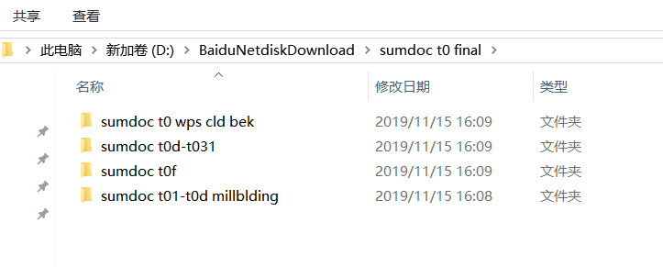

sumdoc taf